SHEYNA'S SITUATION
Directions

Read the story below. Then follow the directions on the next page.

Sheyna's first year of high school is off to a rough start. She was a CIT (counselor in training) at a day camp this summer and loved every minute of it. But now Sheyna misses camp and feels like she can't relate to her school friends anymore.
Every evening, Sheyna IMs (instant messages) Nick, the assistant director of her camp. He just graduated from college and lives a few hours away from her. Nick and Sheyna didn’t know each other that well, but they exchanged screen names at the end of the summer. Sheyna talks to Nick about how much she misses camp and why she's frustrated with her friends. Nick is funny, flirty, and great at giving advice. "Those girls sound so immature," he tells her. "You might as well be in college. Seriously. You act way cooler than any 14-year-old I know."

A few weeks after school starts, Nick starts flirting with Sheyna more obviously:
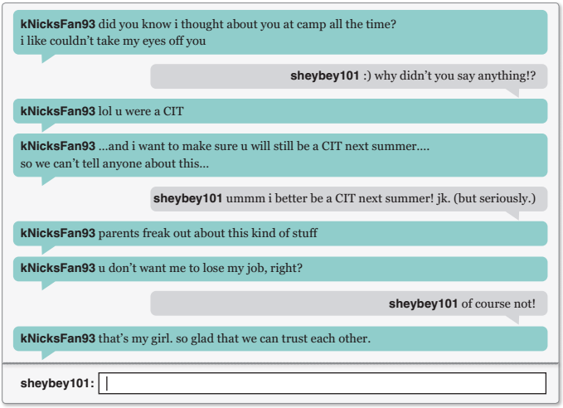

Nick then asks Sheyna to send him some pictures of her in her bathing suit at camp. Sheyna is flattered, but it makes her feel a little uncomfortable. She decides to send the pictures anyway. Nick always talks about how mature she seems, and she doesn’t want to make him think otherwise.
One day after soccer practice, Sheyna’s best friend, Grace, asks to borrow her phone. Without trying to snoop, Grace sees a few sexts (sexually explicit text messages) between Sheyna and Nick. Grace doesn’t know much about Nick, which is strange because she and Sheyna usually tell each other about their crushes. Grace decides to ask Sheyna about her relationship with Nick.

Directions
Based on the story you just read, answer the following questions as if you were Sheyna on the left and Grace on the right. Write your responses in the table below, and paste a screen capture into your Digital Citizenship OneNote binder
Shayna’s Viewpoint: | Grace’s Viewpoint:
1. How did you meet Nick, and how often do you talk to him? | 1. Does it seem like Nick is manipulating Sheyna? Why or why not?
Response: | Response:
2. Is Nick older than you? By how much? | 2. Why might this be a sensitive issue for Sheyna?
Response: | Response:
3. Has Nick ever asked you to keep your relationship secret? In what way? | 3. What advice would you give Sheyna about her relationship with Nick?
Response: | Response:
4. Have you ever felt uncomfortable with anything that Nick has asked you to do?
Response:

