Same Search

Directions
Cole and Lola are both searching online for great deals on boots. They both type the word “boots” into the same search engine. The search results and ads that turn up are shown below. Work in pairs to review their results and answer the questions that follow. Circle or highlight any examples from the results that will help you answer the questions.

When you finish, take a screen capture of your answers and paste into your OneNote Binder under Data > Same Search

- Cole’s Online Search for “Boots””
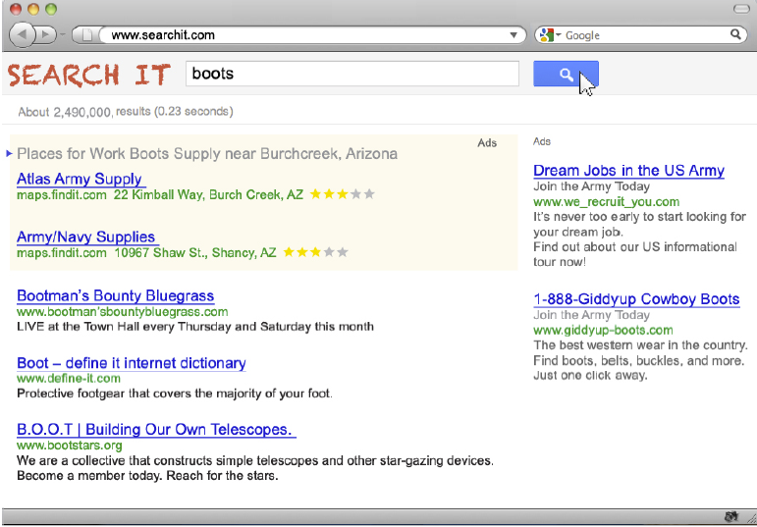

- Lola’s Online Search for “Boots”:
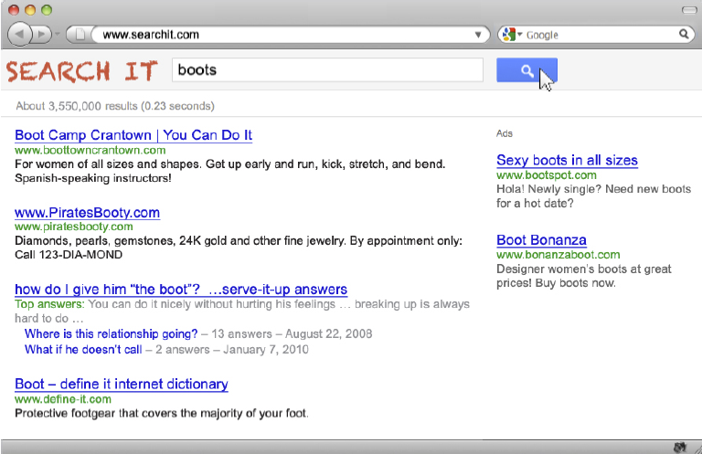

“Same Survey” Questions:

- Based on the search results and ads for Cole and Lola, what kind of demographic data (gender, age, location) do you think companies had collected about each one of them?
  - Click here to enter text.
- What is your evidence?
  - Click here to enter text.
- What kind of previous searches might they have done, or which sites might they have visited before searching for “boots” ?
  - Click here to enter text.
- Do you think it is fair for companies to return different search results for Cole than for Lola?
  - Click here to enter text.
- How about for people in general?
  - Click here to enter text.
- Complete the chart on the next page stating the benefits and risks for ourselves and for the community of Internet users in general when companies give different news, information, and ads to different people.

 | Benefits |  | Risks
Ads | Individual | Community | Individual | Community
Search
Results

